**Whitegates Respite Service**

Whitegates, Sparken Hill, Worksop, Nottinghamshire, S80 1AP

**Telephone:** 01909 776932

**Registered Manager:** Katie Threlfall

**Email:** katie.threlfall@aem.org.uk

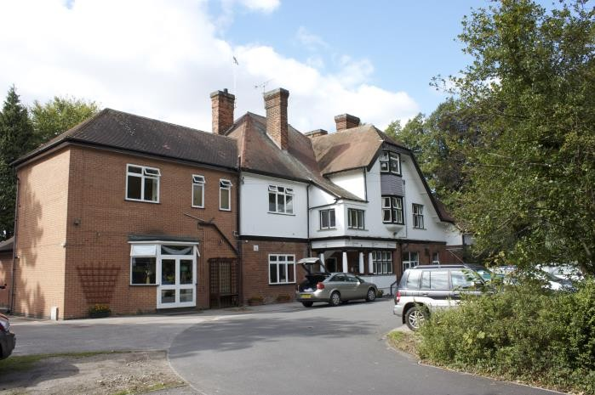

**Registered Provider**

Autism East Midlands, Unit 31, Crags Industrial Estate, Morvern Street, Creswell, Nottinghamshire, S80 4AJ.

www.aem.org.uk Email: enquiries@aem.org.uk Tel: 01909 506678

**Nominated Individual:** Ben Brown, Head of Quality and Operations

**Telephone:** 01909 506678

**Email:** ben.brown@aem.org.uk

**Our Vision**

“ A world which recognises, understands and values autistic people, and where they, and their family, receive the service and support they need throughout their lives”

**Our Mission**

To advocate, provide, and develop high-quality services, information, and support, in

partnership with others, for all those whose lives are affected by autism.

To recognise and respond to the needs of the individual, enabling people with autism to live

their lives with dignity, choice, and independence.

Our well-trained and passionate staff offer a wide range of services to help individuals to live

their lives the way they want.

**Philosophy, Aims and Objectives**

Autism East Midlands’ philosophy is to advocate that adults with an autism spectrum condition should live their lives with dignity, choice and independence to the maximum of their ability. Autism East Midlands provides access to an internal Positive Behaviour Support Team that works in partnership with the people supported by the Whitegates staff team, as well as people being supported to access external agencies and professionals when necessary.

The well-being and progression of our individuals is our underlying ethos. All individuals are given respect and time to achieve their own personal level of attainment with a focus on outcomes; individuals are offered choice, opportunities, and they are supported in the choices they make. Support packages are tailored to individual needs and choices, maximizing dignity and control.

Person-centred support plans are designed to offer additional help with communication and social skills to compensate for impairment with social imagination. A Person-Centred Plan and Positive Behaviour Support Plan are promoted throughout Autism East Midlands. The use of communication aids such as signs & symbols, objects of reference, picture boards, social stories, Brain in Hand, and talking mats all aid in maximizing the choice and control of our individuals.

Autism East Midlands won the’ Charity Times Award 2016’ for best use of assistive technology for the work across all services with service users to increase their ability to communicate with assistive strategies.

Individuals have access to a good range of fulfilling social and leisure activities, and people are supported to maintain good contact with their families, friends and local community. All of our individuals are enabled and supported to make choices and take responsible risks in order to increase their independence. Providing this support is regarded as a fundamental part of staff duties.

Acknowledgement is given to the Mental Capacity Act 2005, Deprivation of Liberty safeguarding, Dignity in Care 10-point Challenge in the development of Person-Centred Support Plans. Autism East Midlands is proactive in supporting individuals to engage with independent advocacy services and the IMCA service where appropriate.

Whitesgates Respite is registered with the Care Quality Commission to provide:

**Accommodation for persons who require nursing or personal care**

**About Whitegates Respite**

Whitegates Respite is a newly established short stay respite service located in Worksop, Nottinghamshire and close to the town centre of Worksop (it can be reached in a care in just a few minutes and on foot in 10 minutes). The site used to be a residential service and has been fully developed into 6 purpose-built flats, with accommodation for staff quarters (sleep in) and substantial grounds. Whitegates is a short stay respite service and will not provide permenant or long stay accommodation.

Whitegates Respite is a building which is split into six units of accommodation, three on the ground floor and three on the first floor. Whitegates has a shared large garden situated across three levels and includes outdoor gym equipment and a hot tub. The accommodation overlooks a picturesque landscape and the location is quiet, providing a peaceful and calming environment for service users. The respite units offer bespoke facilities that have been purpose built for individuals with autism; considering sensory needs and providing ideal environments to help nurture and develop skills for life and independence.

**Principles**

Whitegates offers a wide range of social activities. Individual’s hobbies and leisure interests are also fully supported.

The operation of Whitegates Respite is the overall responsibility of the Registered Manager. Views and ideas are listened to, and wherever possible, acted upon.

Support plans, risk assessments and positive behaviour support plans are informed by the wishes, needs and preferences of the service users at Whitegates Respite. Where the views of the service user cannot be obtained; information about the individual from those who know them best are used to shape support.

Whitegates Respite has a commitment to safeguarding service users and has robust safeguarding policies and procedures in place. All staff members that work at Whitegates Respite have DBS checks before offering employment and complete safeguarding training before entering service.

We cater for the personal dietary needs, or any other requirements of each individual.

There is a formal complaints procedure in place which is also available in easy read format.

**The Support Team**

The service is managed by an appropriately qualified and experienced manager (minimum NVQ level IV).

All staff have received an enhanced DBS and training appropriate to their role. This includes but is not confined to: -

➢ Autism Awareness

➢ Safeguarding Adults

➢ Mental Capacity Act

➢ Deprivation of Liberty Safeguards

➢ Total Communication

➢ First Aid

➢ Food Safety and Hygiene

➢ Moving & Handling

➢ Safe handling of medication

➢ Health & Safety

➢ Risk Assessments

➢ Equality & Diversity

➢ Fire Safety

➢ Infection Control

➢ Epilepsy

➢ Positive Behaviour Support training

➢ Physical Intervention Training (CALM)

➢ Physical Intervention Theory Training (CALM)

All staff complete the above in the dedicated 2-week induction they complete before being introduced to service.

Training needs and opportunities for further development are identified through supervision and annual appraisal for all staff. All staff have a professional responsibility to respect the rights of service users, treat them with respect and dignity, and protect them as far as possible from danger or harm.

**Recruitment**

Autism East Midlands has a robust recruitment procedure in place that aligns to CQC safer recruitment standards. Records include an application form, satisfactory references, and an Enhanced Disclosure and Barring Check. Service users are, wherever possible, involved in the interview process.

**Referral, Admission, and Assessment**

Information is available to help people to decide if our Whitegates Respite can meet their needs and to tell them how the service operates. Our service placement operation guidelines and procedures help in ensuring that a prospective individual receives an assessment to determine whether the service is able to meet their needs before being considered for support.

**Quality Assurance**

Whitegates Respite is monitored and evaluated by internal and external bodies. These include:

* The service users' feedback
* Autism East Midlands Quality Framework
* Regular reviews by funding authorities for the people we support
* CQC for any people supported with regulated activities.
* Regular internal review of support plans and outcomes
* Parent / Carer feedback