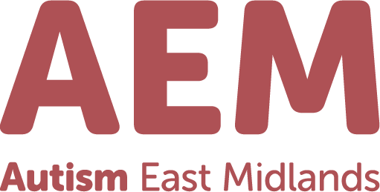

Community Support Hub Team Leader
37 Hours Per Week
£32,714.78 per annum
Autism East Midlands is a leading charitable organisation dedicated to supporting individuals with autism to live fulfilling and independent lives. We provide a wide range of high-quality services tailored to meet the needs of the people we support across the region.
About the Service
Our Community Support Service delivers personalised, one-to-one support to autistic adults across Derbyshire and the wider East Midlands. Operating from our Day Provision base in Heanor, the service is designed to promote independence, autonomy, confidence, and meaningful community engagement.
Our highly committed Community Support Workers empower individuals to:
- Develop essential life skills
- Enhance communication and social interaction
- Access new and meaningful leisure opportunities
- Participate in community and social events
- Prepare for employment and volunteering opportunities
- Build confidence in navigating everyday situations
The Opportunity
As we expand our Community Support Service, we are seeking a Community Support Hub Team Leader to drive this growth across the region.
This is an exciting leadership role where you will:
- Lead the development and expansion of the service across multiple localities
- Manage, support, and inspire a large, geographically dispersed team of practitioners
- Ensure consistently high standards of delivery and person-centred practice
- Champion innovation, quality, and continuous improvement
- Work collaboratively with stakeholders to enhance service reach and impact
Grade: | Team Leader |  | Job Title: | Community Support Services Team Leader
Department: | Adult Services |  | Accountable to: | Service Manager
Responsible for: |  | Service Staff Team
The role:
 | Essential/ Desirable
Experience  1:1 Experience of working with people with learning disabilities or autism  1:2 Experience of managing teams including conducting staff supervisions, appraisals and other staff management systems  1:3 Experience of managing geographically dispersed teams working in the community | E  D  D
Qualifications and Training  2:1 Management qualification (Level 3 or above) | D
Additional skills and knowledge  3:1 Understand and value the rights of people with autism  3:2 Understanding of the legislative framework around community based support and associated codes of practice  3:3 Confident in the use of IT systems such as Microsoft Office  3:4 Confident in the use of CRM systems for client records  3:5 Ability to analyse information, set and prioritise objectives, monitor progress and take corrective action to solve issues  3:6 Understanding of delivering outcome focused support and supporting teams to do the same  3:7 Actively contribute to the wider management team | E  D  E  D  E  E  E
Personal qualities  4:1 Personal and professional commitment to respecting the confidentiality of protected information belonging to both staff and people we support  4:2 Demonstrate a personal and professional commitment to developing self and others with up to date knowledge and training  4:3 Full and current driving licence, with unrestricted access to a car for work | E  E  E

The post holder will be required to undergo an Enhanced DBS check. Any offer of employment will be subject to receipt of satisfactory references and a suitable DBS check.

